Database Design (Part 1)
Aubrey Stevenson |Carson Blin |Francisco Romero | Nick Cousar
February 28th,2021

ER Model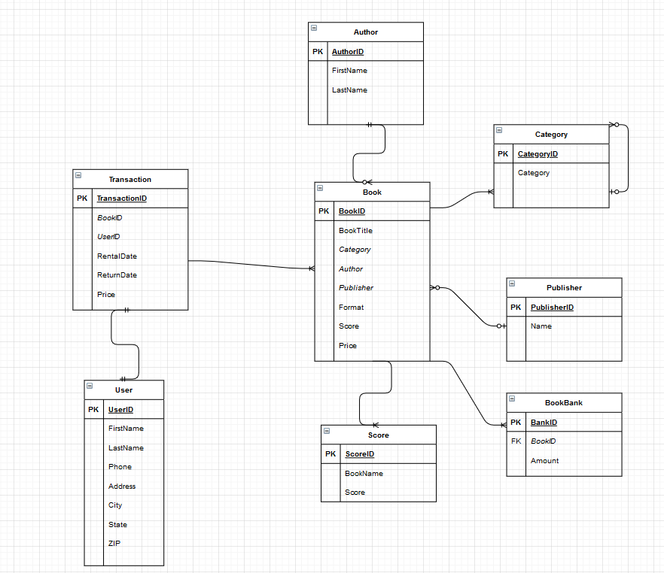

Normalization forms

First Normal Form (1NF)

book1 | title | category | author | publisher | Format ebook, Non ebook | score | price
Normalized into:

book1 | title | category | author | publisher | Format ebook | score | price
book1 | title | category | author | publisher | Format Non ebook | score | price
This table is in 1st normal form because a column of a table cannot hold Multiple values and in this table one book has multiple types and has two values in one column so being separated into two different rows helps to complete the first normal form.
Second Normal Form (2NF)
A once combined table including book bank, category, and author columns is now separated into three tables seen below:
Book bank table with book bank elements...

Category table with category elements...

Author table with all author elements
In order to be in the second number form the table has to be first in the first normal form and has no non-prime columns that are dependent on the proper subset of any candidate key table. The database can be separated into the book bank table, category table, and author table which would give all details of the book in a separated form.

Third Normal Form (3NF)

Book table with book elements...

Book id table with identifying elements...

Book type table with all formats of the books
In order to be in the third normal form a table must be in second normal form and transitive functional dependency of non-prime Ash be used on any super key should be removed. This table is split into three individual tables including ID, name and, type: a second table including all other identifying factors of the book: is there a table including the book types.

Boyce and Codd Normal Form (BCNF)
In order to be in Boyce and Codd normal form the tables must first be in third normal form but also has to have functional dependencies, these tables have functional dependencies:
Book table with book elements...
Book id --------------->title
Book id--------------->Category
Book id--------------->Author
Book id--------------->Publisher
Book id--------------->Format
Book id--------------->Score
Book id--------------->price
Book id table with identifying elements...
Book id--------------->title
Book id--------------->author
Book id--------------->publisher
Book type table with all formats of the books
Book id --------------->format

Table of Functional Dependencies

Determinant | Dependent
Transaction id ---------------> | bookid,userid,rentaldate,returndate,price
User id ---------------> | Fname,lname,phone number, address,city,state,zip
Book id ---------------> | title,category,author,publisher,format,score,price
Author id ---------------> | First name, last name
Category id ---------------> | category
Publisher id ---------------> | Publisher name
Score id ---------------> | Score, book name
Bank id ---------------> | Book id, amount

Relationships
- Weak entity sets (ID-dependent, Non-ID-dependent).
User + transaction = book = id dependent
- 1:1 strong entity relationships.
1 transaction to 1 Book
- 1:N strong entity relationships.
1 book to many reviews
- N:M strong entity relationships,
Many customers to many transactions
- associative entities.
Transaction table (needs book id and customer id from book and user table)
- Entity subtypes.
Book type(Available books, sold books, rented books), category of books(different genres), rental date(<15 days, <15days, etc)
- Recursive relationships.
Admin and customer

SQL Code
CREATE Table User(
UserID int AUTO_INCREMENT,
FirstName varchar(20) NOT NULL,
LastName varchar(20) NOT NULL,
Phone varchar(20) NOT NULL,
Address varchar(50) NOT NULL,
City varchar(30) NOT NULL,
State varchar(20) NOT NULL,
ZIP int NOT NULL,
PRIMARY KEY (UserID)
);
CREATE Table Score(
ScoreID int AUTO_INCREMENT,
BookName varchar(30) NOT NULL,
Score int NOT NULL,
PRIMARY KEY (ScoreID)
);
CREATE Table Publisher(
PublisherID int AUTO_INCREMENT,
Name varchar(30),
PRIMARY KEY (PublisherID)
);

CREATE Table Author(
AuthorrID int AUTO_INCREMENT,
AuthorName varchar(30),
PRIMARY KEY (AuthorID)
);

CREATE TABLE Category(
CategoryID int AUTO_INCREMENT,
Category char(20),
PRIMARY KEY (CategoryID)
);

CREATE Table Book(
BookID int AUTO_INCREMENT,
Category char(20) NOT NULL,
Author varchar(20),
Publisher varchar(30) NOT NULL,
Format char(10) NOT NULL,
Score int,
Price decimal(4,2) NOT NULL,
PRIMARY KEY (BookID),
FOREIGN KEY(Category) REFERENCES Category(CategoryID),
FOREIGN KEY(Author) REFERENCES Author(AuthorID),
FOREIGN KEY(Publisher) REFERENCES Publisher(PublisherID),
FOREIGN KEY(Score) REFERENCES Score(ScoreID)
);

CREATE Table BookBank (
BankID int NOT NULL,
BookID int NOT NULL,
Amount int NOT NULL,
PRIMARY KEY (BankID),
FOREIGN KEY(BookID) REFERENCES Book(BookID)
);

CREATE Table Transaction (
TransactionID int AUTO_INCREMENT,
BookID int NOT NULL,
UserID int NOT NULL,
RentalDate date,
ReturnDate date,
Price decimal(4,2),
PRIMARY KEY (TransactionID),
FOREIGN KEY (BookID) REFERENCES Book(BookID),
FOREIGN KEY (UserID) REFERENCES User(UserID)
);

INSERT INTO User(NULL, ‘Tom’, ‘Derk’, ‘904-345-2341’, ‘452 Fern Avenue’, ‘Jacksonville’, ‘FL’);
INSERT INTO User(NULL, ‘James’, ‘Harr’, ‘904-341-7451’, ‘3541 Mandarin Street’, ‘Jacksonville’, ‘FL’);
INSERT INTO User(NULL, ‘Amy’, ‘Penn’, ‘904-345-4816’, ‘452 Fern Avenue’, ‘Jacksonville’, ‘FL’);

INSERT INTO Score(NULL, ‘The Hunger Games’, ‘4’);
INSERT INTO Score(NULL, ‘Book of Truths, ‘3’);
INSERT INTO Score(NULL, ‘Divergent’, ‘4’);

INSERT INTO Publisher(NULL, ‘Scholastic Corporation’, ‘4’);
INSERT INTO Publisher(NULL, ‘‘Katherine Tegen Books’, ‘4’);
INSERT INTO Publisher(NULL, ‘‘Katherine Tegen Books’, ‘4’);

INSERT INTO Author(NULL, ‘Suzanne Collins’);
INSERT INTO Author(NULL, ‘Ashley Mank’);
INSERT INTO Author(NULL, ‘Veronica Roth’);

INSERT INTO Category(NULL, ‘Dystopian’);
INSERT INTO Category(NULL, ‘Drama’);
INSERT INTO Category(NULL, ‘Science Fiction’);

INSERT INTO BookBank(NULL,NULL,‘The Hunger Games’, ‘43’);
INSERT INTO BookBank(NULL,NULL, ‘Book of Truths’, ‘57’);
INSERT INTO BookBank(NULL,NULL, ‘Divergent’, ‘12’);

INSERT INTO Book(NULL, ‘The Hunger Games’, ‘Dystopian’, ‘Suzanne Collins’, ‘Scholastic Corporation’, ‘Hardcover’, ‘4’, ‘18.99’);
INSERT INTO Book(NULL, ‘Book of Truths’, ‘Drama’, ‘Ashley Mank’, ‘Scholastic Corporation’, ‘Kindle’, ‘3’, ‘19.99’);
INSERT INTO Book(NULL, ‘Divergent’, ‘Science Fiction’, ‘Veronica Roth’, ‘Katherine Tegen Books’, ‘Hardcover’, ‘4’, ‘14.99’);

INSERT INTO Transaction(NULL, NULL, ‘2021-2-21’, ‘2021-3-21’, ‘18.99’);
INSERT INTO Transaction(NULL, NULL, ‘2021-2-15’, ‘2021-3-15’, ‘19.99’);
INSERT INTO Transaction(NULL, NULL, ‘2021-2-3’, ‘2021-3-3’, ‘14.99’);

